**Day1 C# : Task3**

***Visual Studio Project Setup Diary***

***Step-1 :***  O*pen web-browser and type url “****visualstudio.microsoft.com/vs/****”*

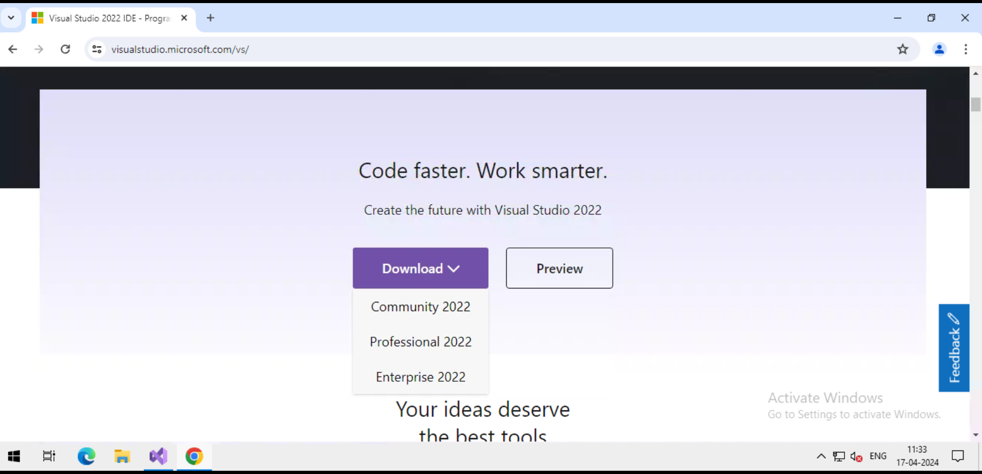

***Step-2:***  *click on which version you want and download it*

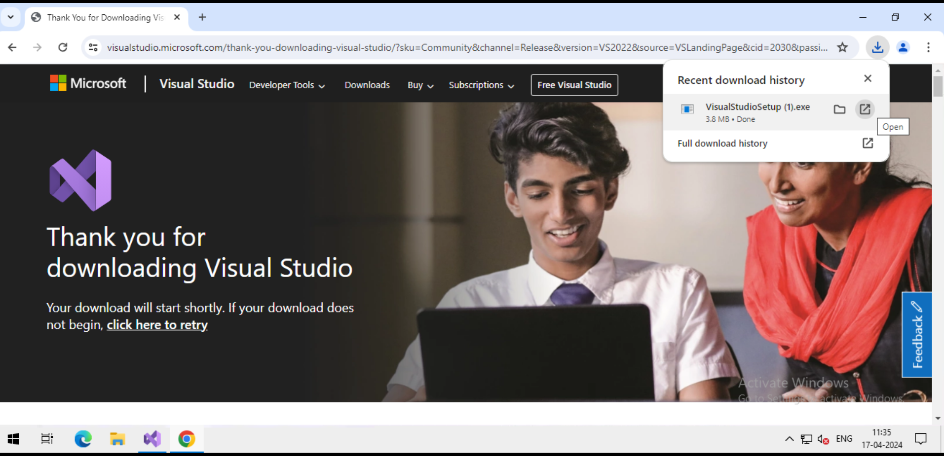

***Step-3:*** then click on “**open** “ that shown in upper image

***step-4:*** after click on “**open**” a window open like this click on “**Run**”

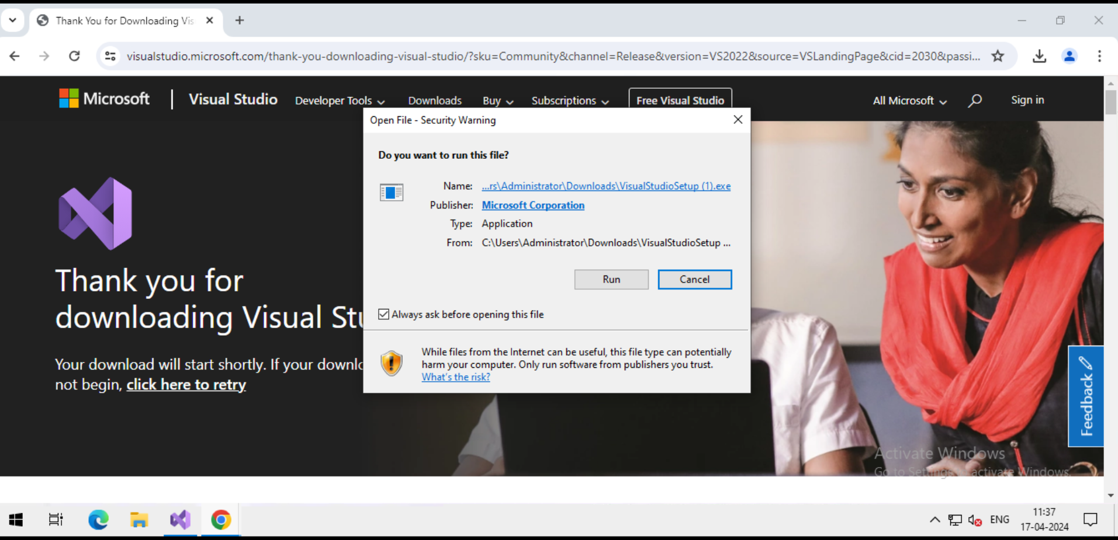

***Step-5:*** *after click on “****Run”*** *installer menu will display here click on “****Continue****”.*

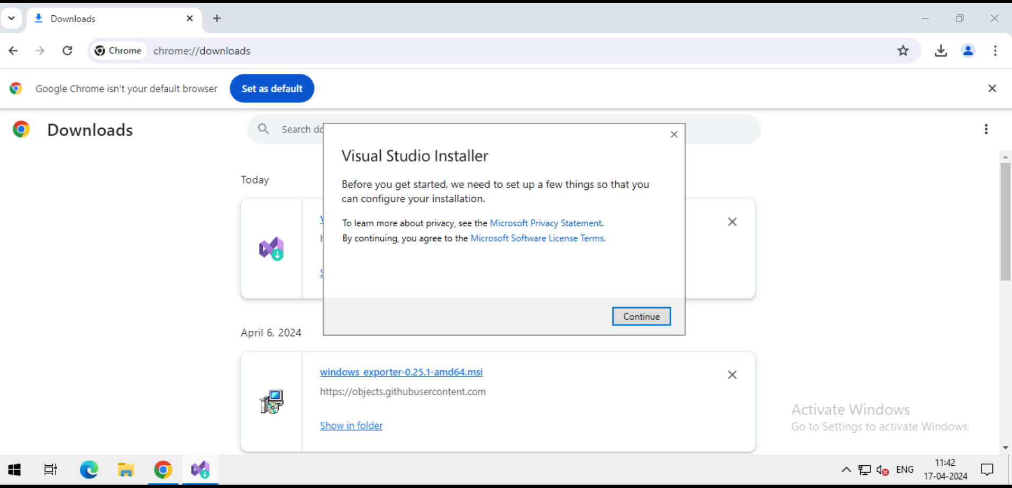

***Step-6:*** *installation will happening like shown in below pic after you click on “****Continue****”.*

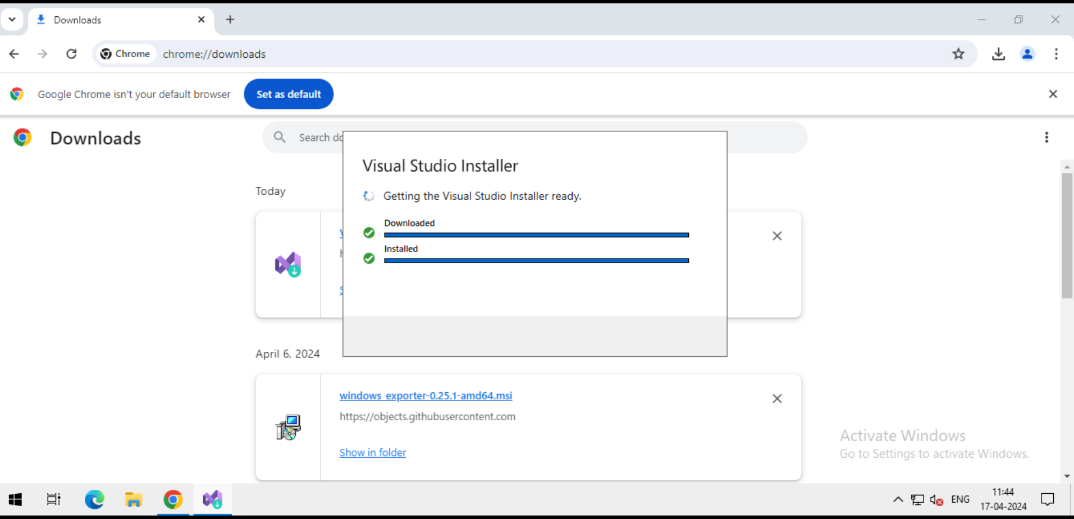

***step-7:*** after installation if window will appear like this . click on “**Modify**”

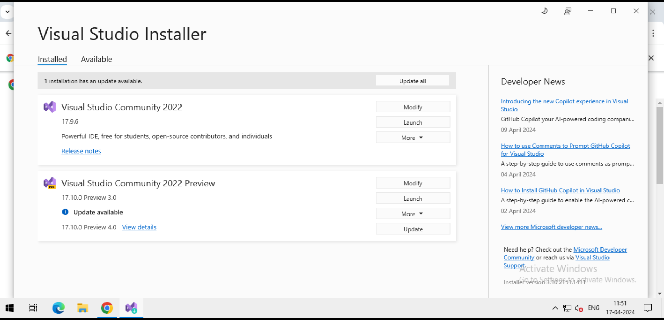

***Step-8:*** *now choose “****Workloads, Individual Components, Language packs, Installation locations****” you want.*

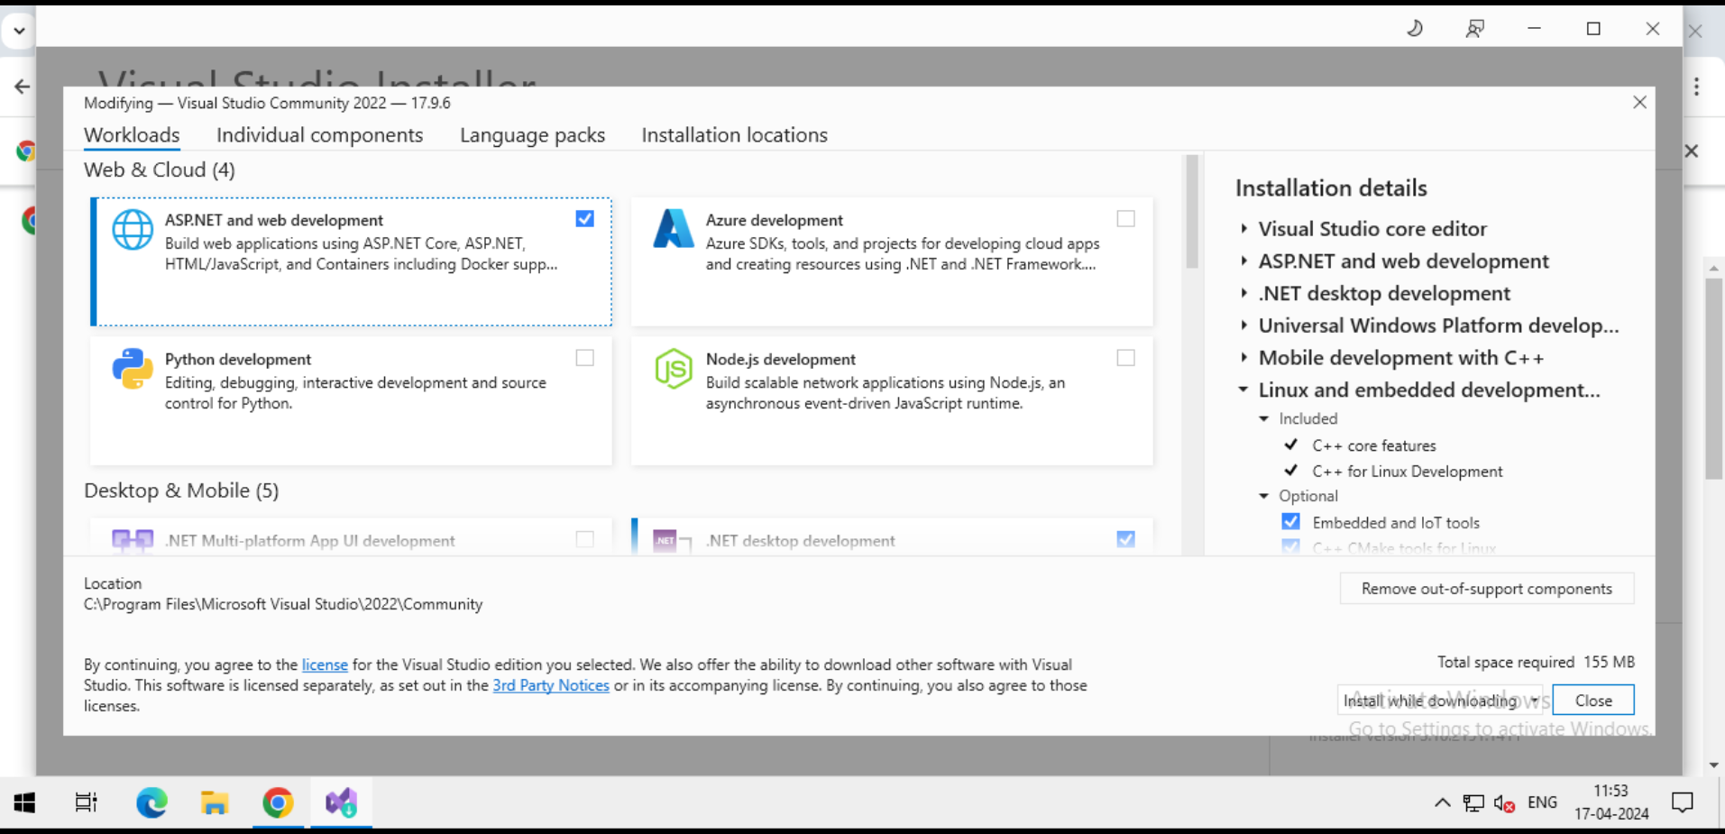

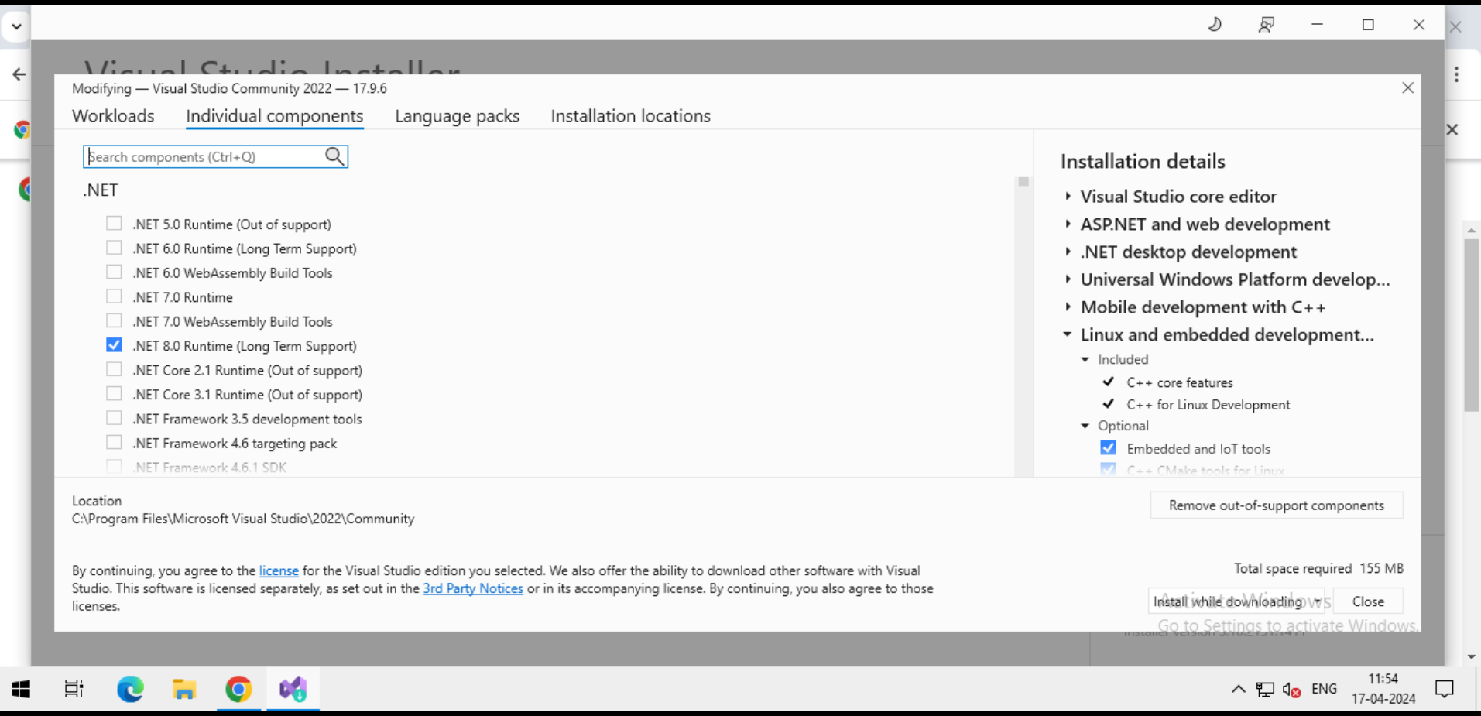

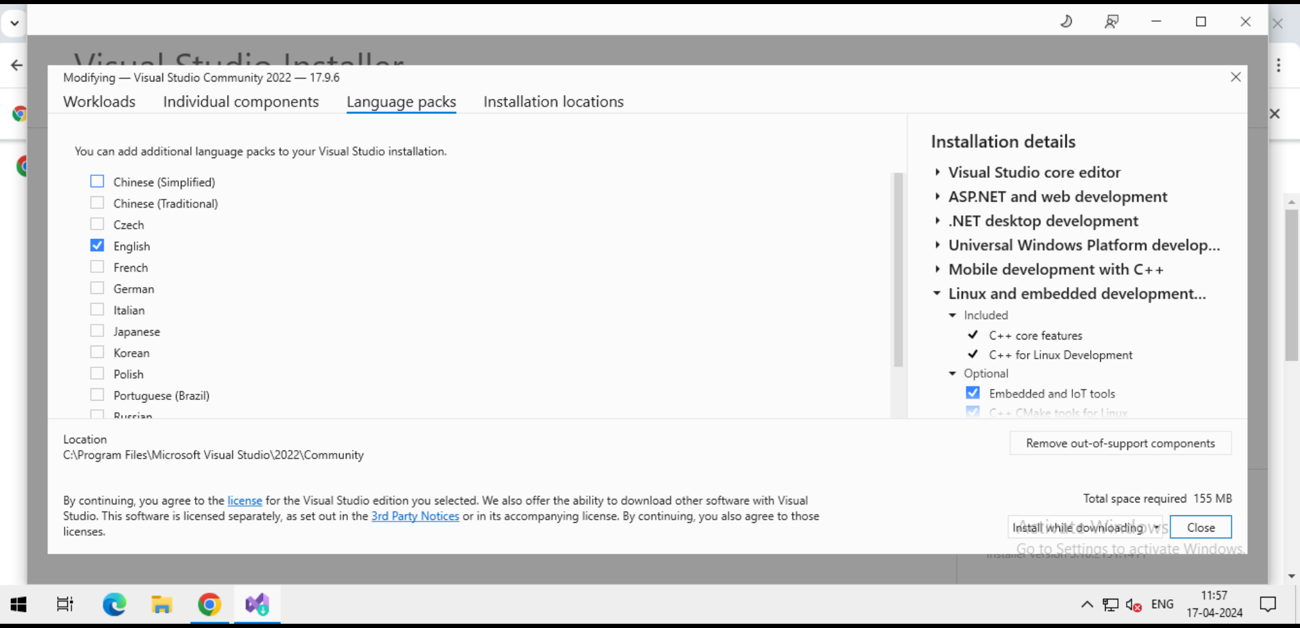

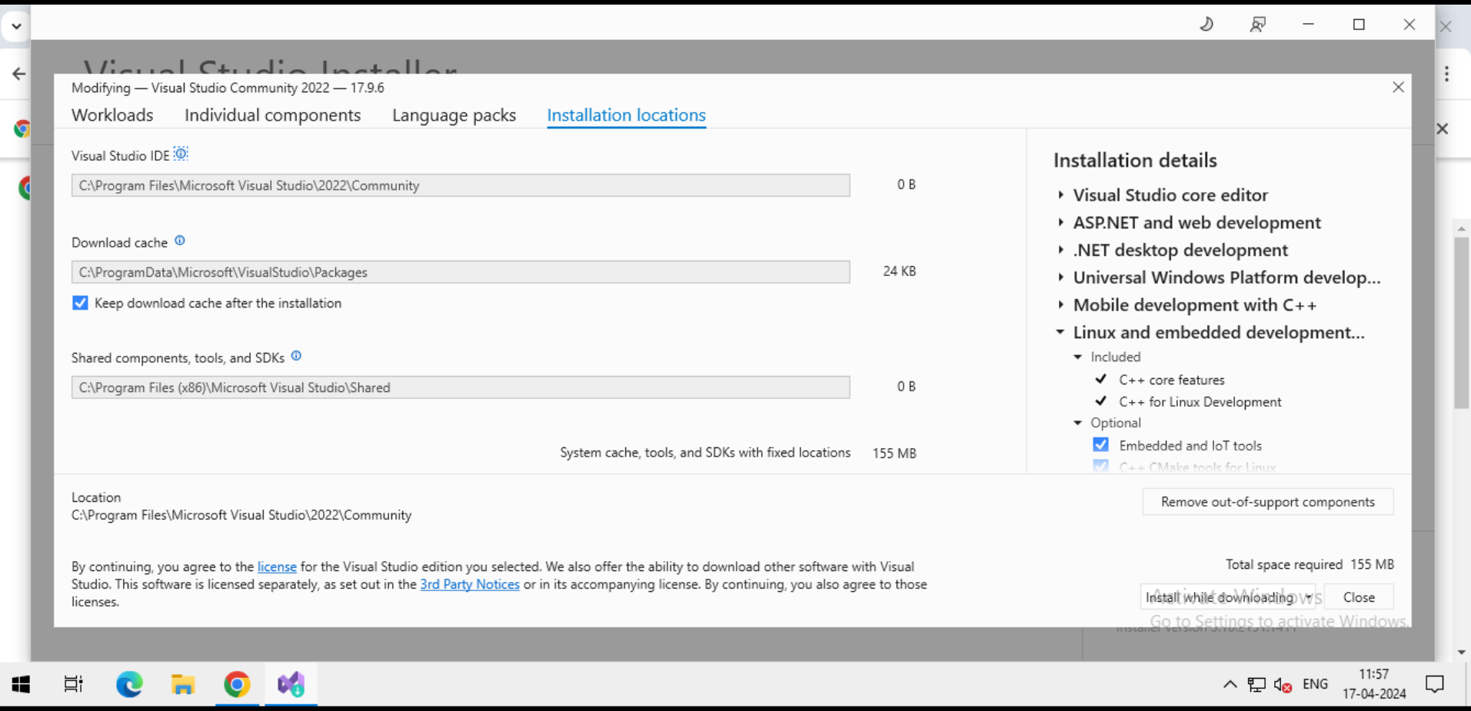

***Step-9:*** *Click on “I****nstall while downloading****” then click on “****Close****” then it will be download what we select and then install those after installation click on “****Launch****”*

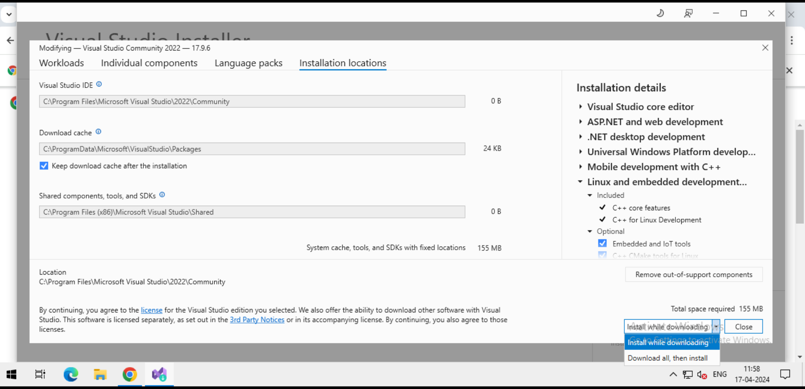

***Step-10:*** *Window will appear like this. click on “****Create new project****” to create our first project*

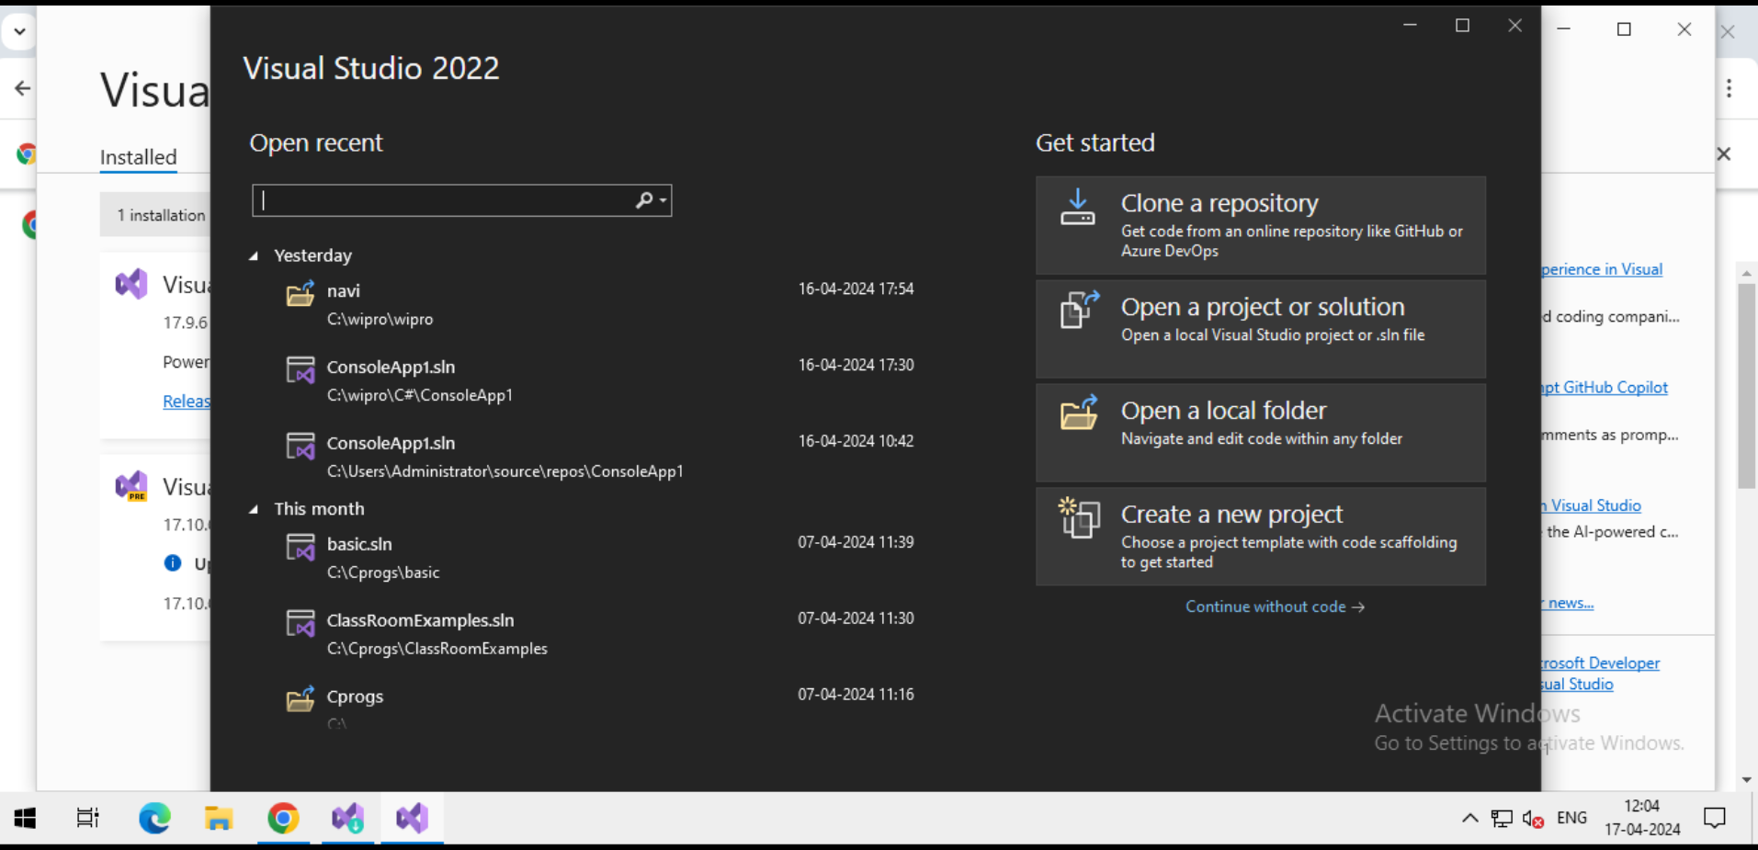

***Step-11:*** *After click on “****Create new project****” a window like this will appear here you can choose in which laguage you want make project and what kind of platform it will run and consoles and then click on* ***“Next”***

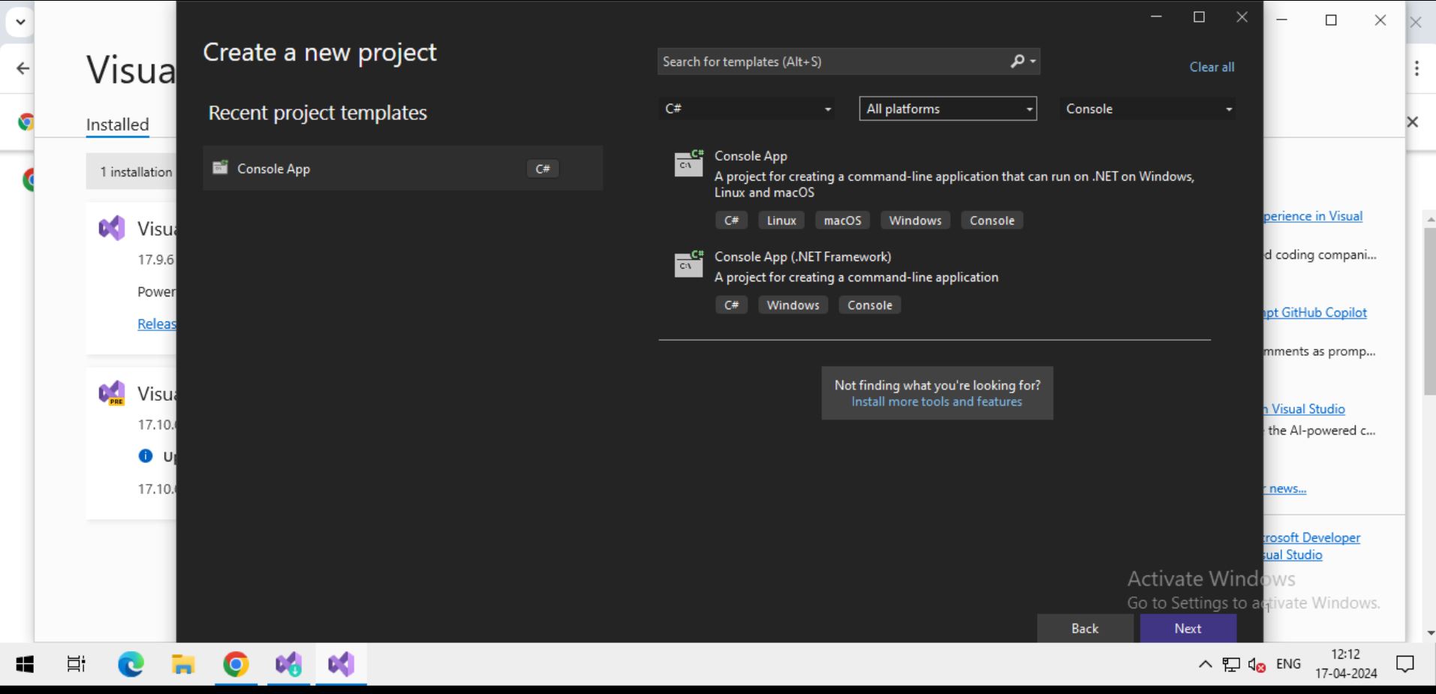

***Step-12:***  *After click on “****Next****” a window will display like this here you can give your project name in “****Project name****” and also you can specify path In “****Location****” section and “****Solution name****“ (Container) also then click on “****Next****”.*

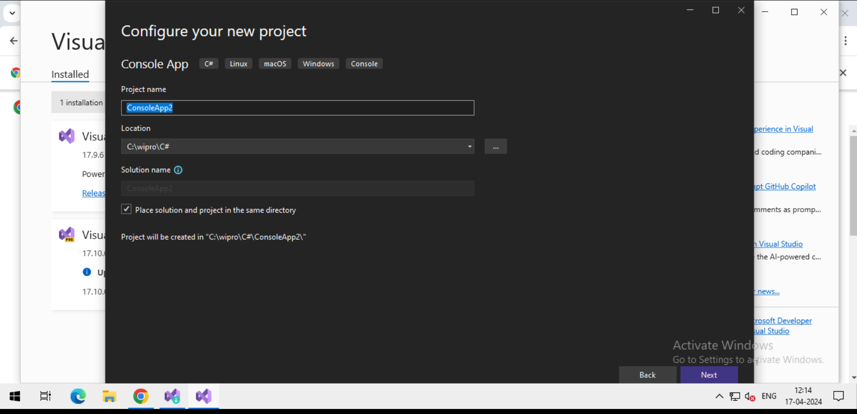

***Step-13:*** *In the next step you can choose “****Framework”***  *version based on your requirement*. then clck on “**Create**”.

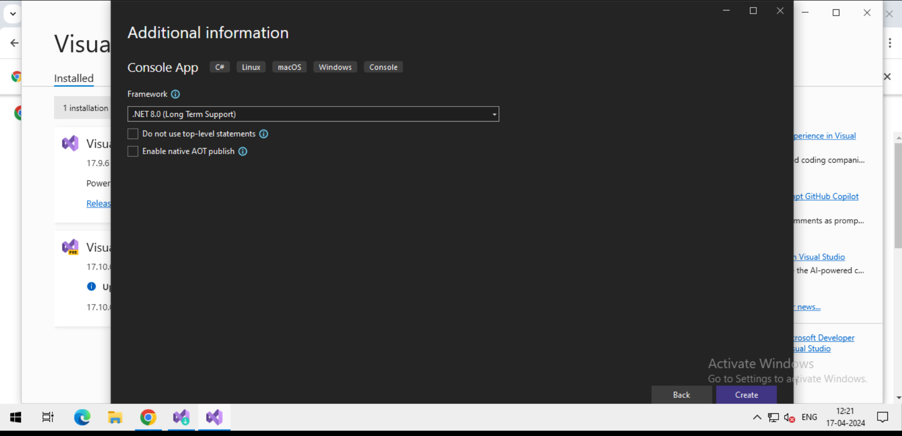

***Step-14:*** *Congrats your project created now you can write code for your project .*

